Đề bài
Practice: Kotlin Fundamentals
https://developer.android.com/codelabs/basic-android-kotlin-compose-kotlin-fundamentals-practice-problems

Bài 1. Mobile notifications
Mã nguồn
// Bach Minh Quang - 202490077
// Bai 1. Mobile notifications

fun main() {
val morningNotification = 51
val eveningNotification = 135

printNotificationSummary(morningNotification)
printNotificationSummary(eveningNotification)
}

fun printNotificationSummary(numberOfMessages: Int) {
if (numberOfMessages < 100) {
println("You have ${numberOfMessages} notifications.")
} else {
println("Your phone is blowing up! You have 99+ notifications.")
}
}

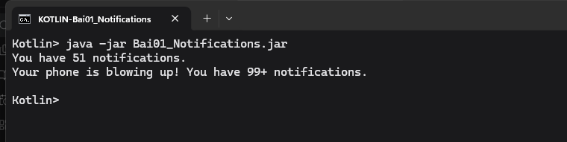

Bài 2. Movie-ticket price
Mã nguồn
// Bach Minh Quang - 202490077
// Bai 2. Movie-ticket price

fun main() {
val child = 5
val adult = 28
val senior = 87

val isMonday = true

println("The movie ticket price for a person aged $child is \$${ticketPrice(child, isMonday)}.")
println("The movie ticket price for a person aged $adult is \$${ticketPrice(adult, isMonday)}.")
println("The movie ticket price for a person aged $senior is \$${ticketPrice(senior, isMonday)}.")
}

fun ticketPrice(age: Int, isMonday: Boolean): Int {
return when (age) {
in 0..12 -> 15
in 13..60 -> if (isMonday) 25 else 30
in 61..100 -> 20
else -> -1
}
}
Kết quả chạy thử
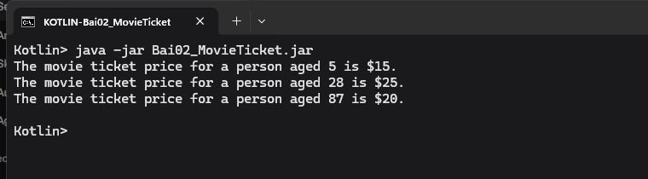

Bài 3. Temperature converter
Mã nguồn
// Bach Minh Quang - 202490077
// Bai 3. Temperature converter
// Locale.US keeps the decimal point required by the exercise on every machine locale.

import java.util.Locale

fun main() {
printFinalTemperature(27.0, "Celsius", "Fahrenheit") { 9.0 / 5.0 * it + 32 }
printFinalTemperature(350.0, "Kelvin", "Celsius") { it - 273.15 }
printFinalTemperature(10.0, "Fahrenheit", "Kelvin") { 5.0 / 9.0 * (it - 32) + 273.15 }
}

fun printFinalTemperature(
initialMeasurement: Double,
initialUnit: String,
finalUnit: String,
conversionFormula: (Double) -> Double
) {
val finalMeasurement = String.format(Locale.US, "%.2f", conversionFormula(initialMeasurement))
println("$initialMeasurement degrees $initialUnit is $finalMeasurement degrees $finalUnit.")
}
Kết quả chạy thử
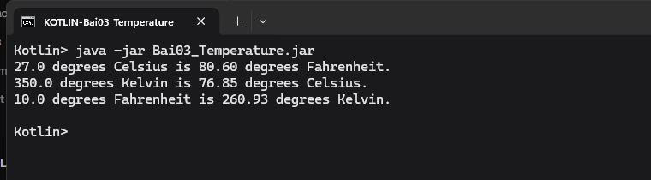
Hình 3. Kết quả chạy Bài 3. Temperature converter
Khớp đề. 27.0 °C = 80.60 °F. 350.0 K = 76.85 °C. 10.0 °F = 260.93 K.

Bài 4. Song catalog
Mã nguồn
// Bach Minh Quang - 202490077
// Bai 4. Song catalog

fun main() {
val brunoSong = Song("We Don't Talk About Bruno", "Encanto Cast", 2022, 1_000_000)
brunoSong.printDescription()
println(brunoSong.isPopular)
}

class Song(
val title: String,
val artist: String,
val yearPublished: Int,
val playCount: Int
) {
val isPopular: Boolean
get() = playCount >= 1000

fun printDescription() {
println("$title, performed by $artist, was released in $yearPublished.")
}
}

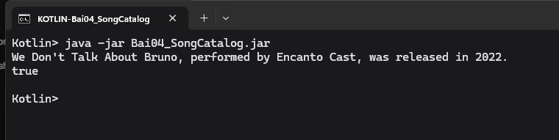

Bài 5. Internet profile
Mã nguồn
// Bach Minh Quang - 202490077
// Bai 5. Internet profile

fun main() {
val amanda = Person("Amanda", 33, "play tennis", null)
val atiqah = Person("Atiqah", 28, "climb", amanda)

amanda.showProfile()
atiqah.showProfile()
}

class Person(val name: String, val age: Int, val hobby: String?, val referrer: Person?) {
fun showProfile() {
println("Name: $name")
println("Age: $age")
if (hobby != null) {
print("Likes to $hobby. ")
}
if (referrer != null) {
print("Has a referrer named ${referrer.name}")
if (referrer.hobby != null) {
print(", who likes to ${referrer.hobby}.")
} else {
print(".")
}
} else {
print("Doesn't have a referrer.")
}
print("\n\n")
}
}
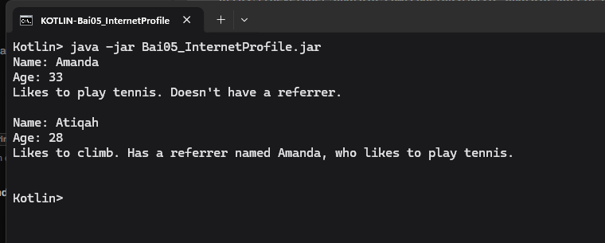

Bài 6. Foldable phones
Mã nguồn
// Bach Minh Quang - 202490077
// Bai 6. Foldable phones

open class Phone(var isScreenLightOn: Boolean = false) {
open fun switchOn() {
isScreenLightOn = true
}

fun switchOff() {
isScreenLightOn = false
}

fun checkPhoneScreenLight() {
val phoneScreenLight = if (isScreenLightOn) "on" else "off"
println("The phone screen's light is $phoneScreenLight.")
}
}

class FoldablePhone(var isFolded: Boolean = true) : Phone() {
override fun switchOn() {
if (!isFolded) {
isScreenLightOn = true
}
}

fun fold() {
isFolded = true
}

fun unfold() {
isFolded = false
}
}

fun main() {
val newFoldablePhone = FoldablePhone()

newFoldablePhone.switchOn()
newFoldablePhone.checkPhoneScreenLight()
newFoldablePhone.unfold()
newFoldablePhone.switchOn()
newFoldablePhone.checkPhoneScreenLight()
}

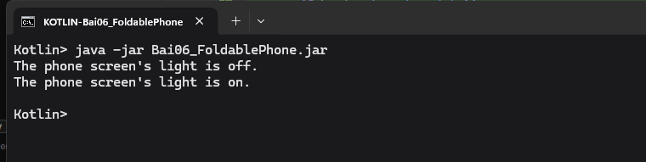

Bài 7. Special auction
Mã nguồn
// Bach Minh Quang - 202490077
// Bai 7. Special auction

fun main() {
val winningBid = Bid(5000, "Private Collector")

println("Item A is sold at ${auctionPrice(winningBid, 2000)}.")
println("Item B is sold at ${auctionPrice(null, 3000)}.")
}

class Bid(val amount: Int, val bidder: String)

fun auctionPrice(bid: Bid?, minimumPrice: Int): Int {
return bid?.amount ?: minimumPrice
}

